Resources for WHCCA Neighbors
4/27/24
- WHCCA website http://whcca.org

- WHCCA Facebook Page https://www.facebook.com/MyWHCCA This provides for immediate needs, or to communicate with the neighborhood as a whole.

- Nextdoor website https://nextdoor.com/invite/hhmzbbizqqmynfwqhnbp A great resource for finding out what is going on in the surrounding neighborhoods. Our Nextdoor group is Cougar Mountain/Horizon Village.

- Bellevue City resources https://bellevuewa.gov There is a Map Gallery page on the City’s website. In the search bar type in the specific info. you are looking for if not seen on the Home page. Has many tabs and links within all the below links, giving you many more resources.
  - If not sure which department to contact for an issue, and you cannot find it in the below categories, contact “Service First” team at servicefirst@bellevuewa.gov or 425-452-6800.
They are familiar with all aspects of city operations and can help direct you to the appropriate department.

  - Bellevue By the Numbers link to a Bellevue City website for contacting by phone various Bellevue City resources. It is to a brochure in English, Spanish, Russian, Vietnamese, Chinese, and Korean.

  - Code compliance – 425-452-4562 Requirements to comply with the City Codes dealing with construction, vegetation, neighbor conflict etc.

  - Project in Your Neighborhood (PIYN) for short web map. It displays active CIP (Utilities, Parks, Transportation, etc.) and levy projects by project phase. If you click on a point, line, or polygon, it displays info. about the project in the Results Panel on the left side. It even provides the name of the Project Manager (PM) in case resident would like more info about the project. It also shows projects that have been completed within the last year

  - Neighborhood Safety, Connectivity, and Congestion Levy This map (with many tabs at the top) displays specifically the 20-year transportation levy that Bellevue voters approved in 2016. This story map explains about the levy and each of the categories: bike, congestion, maintenance, safety, sidewalks, and traffic technology projects throughout the city that is funded by the levy.

  - “State of Our Neighborhoods”, “Trends In Transit”, “(Fire) Community Risk Assessment”, etc. All of the public-facing maps can be found on the Map Gallery page on the City’s website. Additional maps and info can be found by navigating from the City’s website (bellevuewa.gov), scroll down to the bottom and click on the “Maps and GIS” icon.

  - Tree removal permit requirements. Contact the Land use department: 425-452-4188, Here is a link to the city of Bellevue website that has more information.
https://bellevuewa.gov/city-government/departments/development/zoning-and-land-use/zoning-requirements/trees/tree-removal

- Gas leak – If you smell gas, call Puget Sound Energy (PSE) 1-888-225-5773

- Power Outages – Puget Sound Energy (PSE) 1-888-225-5773

- Streets -Transportation dept. – Dangerous situations, icy roads, report to: 425-452-7840. For non-emergency issues e.g. street signs, street issues, waste water, surface water, email O&MSupport@bellevuewa.gov so that a work order can be created.

- Sidewalk/street maintenance.
  - Sidewalk clearance – homeowners’ responsibility to keep shrubbery trimmed back to the inside edge of the sidewalk and trimmed so a 6’5” person can walk under the tree branches. Land use code 20.20.900 covers the homeowner’s responsibility. More information is also available on the WHCCA.org website.
  - For any further questions or concerns regarding Water, Wastewater, Surface Water, Street & Sign Maintenance, please contact Utilities Operations & Maintenance at 425-452-7840 24 hours a day, 7 days a week. For a complete list of ‘Common Complaint Referrals, please visit http://www.bellevuewa.gov/complaint_referrals.htm.

- Streetlights – Puget Sound Energy (PSE). To report a streetlight is out call 1-888-225-5773 >2 or email customercare@PSE.com . Provide the PSE number on the metal tag on the pole, normally starts with an X…… and the closest house address along with any other information about the light outage. Or you can go to their website and fill out the form to report the outage. https://www.pse.com/outage/report-street-light-outage

- Street Signs – If you see a street sign that is badly faded, or nearly unreadable email:
O&MSupport@bellevuewa.gov and report the location to them. They will make a new sign.

- Garbage – Republic Services 425-452-4762 // 206-682-9735
  - Schedule pick-ups recycle electronics 425-452-4762

- MyBellevue App. is an excellent resource. The App. allows you to request services, access city news, peruse jobs and check social media.

- KingCountyGov/Alert – google to find and sign up for the types of alerts you want to be notified about.

- Criminal Activity:
- Crime: To report a crime, call 911 for emergencies or non-emergency at 425-577-5656. You may also report many crimes online. https://bellevuewa.gov/city-government/departments/police
- Be sure to report to the police any prowling activity, even if nothing is taken. Police need to know about any criminal activity to allocate resources accordingly. Also, your report may give the police a clue that may tie in with other criminal activity.
Prevention:
- To prevent property crimes, the most common type of crime in Bellevue, the police gave the following guidance. For more helpful information and ideas, please check out this link: Crime Prevention | City of Bellevue (bellevuewa.gov) Don’t leave a running vehicle unintended. The #1 most common car theft occurs when owners warm up their vehicle and go back inside to get something.
- Park your vehicle inside your garage.
- If you can’t park inside your garage, park in your driveway. To prevent a thief from using your garage door opener to gain entry into your home, lock the door that leads inside your home. It is best to take the garage door opener inside with you.
- If you can’t park your car in your driveway, pick a well-lit area and (important!) remove ALL valuables, or things that may look valuable or hidden, even remove spare change and charging cables. Thieves will break a window for even small items of value. Do not leave shopping bags or coats over a bundle in view. Thieves assume you are trying to hide something of value. If you intend to put valuables into your trunk for safekeeping, be sure to do this BEFORE you arrive at your destination. Thieves routinely keep watch for people stowing things in their trunk. This is common at trailheads.
- The best way to protect your home is to have good lighting, landscaping, layout and cameras. It is cheaper to spend more for extra security cameras around your house vs. paying more for stolen items and the time it takes to deal with criminal activity impact upon your home.
- The proliferation of cameras on doorbells and other locations does help detectives combat property crime and malicious mischief. A question to the Bellevue Police.
Can you record only locally and not to the cloud? - Cameras - Welcome to the Wyze Forum (wyzecam.com)
- Don’t make trips to your car with packages and go back inside the mall for more shopping, especially during the holiday shopping season. Thieves watch for this in mall parking lots and then break into the vehicle to steal your bags. Better to leave your packages at the store or a centralized bag check area if you cannot carry all your purchases with you.
- BPD is not seeing vehicle prowls where the thief is targeting your registration card in your glove box and your garage door opener, with the intention of breaking into your home while your car is parked at the mall. Just in case, it is now perfectly acceptable to keep a photo of your registration on your phone. You do not need to show an officer the paper copy. If you photograph your vehicle registration, be sure the bar code shows clearly in the photo, as this is what officers scan when they ask to see your registration.
- Buying something expensive off Facebook Marketplace or Craigslist? Meet with the seller in the BPD parking lot. This will discourage any “sellers” who secretly want to rob you. Report “sellers” who are reluctant to meet in a police parking lot to the websites they are using to “sell” expensive things.
- Paws On Patrol is a fun way to prevent crime in your neighborhood while out walking your dog. It is a chance to observe anything suspicious; participants are extra “eyes and ears” in the neighborhood. Paws On Patrol | City of Bellevue (bellevuewa.gov)
- When you go to bed, check that your garage doors are closed, and the door from the garage going into the house and outside doors are all locked.

- Crime Statistics in WHCCA: The WHCCA neighborhood is very safe with only 10 crimes reported in the 2020: 2 burglaries, 5 property crimes/malicious mischief, 1 vehicle prowl, and 2 other crimes. There were only 100 calls to 9-1-1 over an 18 month period. Some of these calls were for assistance or to report suspicious activity, which did not result in a crime. Homeowners can check local crime
statistics on this site: https://www.crimemapping.com/map/WA/Bellevue (Firefox may not work well.)

- Block Watch Program - Watch groups are the foundation of community crime prevention. We ask for residents contact information so that we can keep you informed. City of Bellevue also has Chinese and other translations. Information on the City of Bellevue website as a PDF document:
https://bellevuewa.gov/sites/default/files/media/pdf_document/Block_Watch.pdf
- Mail and package theft continues to be a problem. Bellevue PD (BPD) recommends signing up for USPS Informed Delivery (Informed Delivery (usps.com) ) to preview the mail that should be in your mailbox. Also sign up for UPS and Amazon delivery notifications. If you are missing mail or a package and suspect a theft, it is important to notify BPD by using the MyBellevue App, or the following link: Report a Crime Online | City of Bellevue (bellevuewa.gov)

- Hate crimes are not rising per se but continue to be a very high priority for BPD. Washington State Law requires proof that a crime was hate-based, so it is very important that if you see or hear something, say something. And if you are not in a position to intervene safely, call 9-1-1 for assistance.

- Emergency Preparedness Reminders from Bellevue Police: In the event of a natural disaster such as a serious earthquake, residents need to prepare to be totally on their own without emergency services for at least 3 days – potentially 2 weeks or more. This is why it is essential that you know what block you live in and who your Block Captain is. These volunteers will coordinate self-sufficiency efforts and know where the Block Emergency Kit is located. Additionally, neighbors need to be prepared for winter storms and occasional power outages. Keep a supply of candles, flashlights, spare batteries and a battery-operated lantern handy. If you don’t own a generator, remember that you can charge your phone in your car, and some trucks can power a refrigerator. Duracell also manufacturers a backup battery with capable of powering appliances with clean energy. (Example: Duracell PowerSource 1440W Portable Power Station – DuracellPower)
  - Emergency kits – A tub with first aid type supplies is in each Block Captain’s garage, or designated resident within the Block.
  - The WHCCA Disaster Plan with Implementation Actions and Emergency Kit list is a separate document.
  - Earthquake notification – Early warning for the West Coast of the United States https://www.shakealert.org
    - King County emergency notification: https://kingcounty.gov/depts/emergency-management/alert-king-county

- Call before you dig - before digging on property, protect yourself from injury or damage.
  - Call 800-424-5555 or go to http://www.callbeforeyoudig.org/washington Click on Homeowners, submit a locate utilities request.
  - Utilities Markings
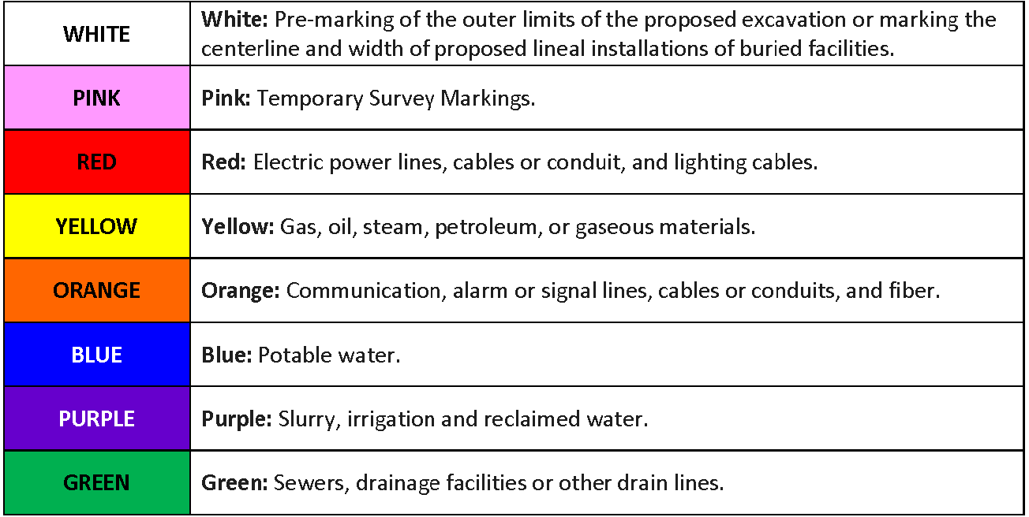

- House numbers – want to be very visible for emergency responders and delivery drivers to easily find your house. There is guidance on the WHCCS.org website.

- Strong community connections strengthen neighborhoods and directly raise the quality of life. Bellevue's City Council affirms this with the city's Great Neighborhood programs.

- Prevent Pet Waste POO-llution Notice from City of Bellevue Utilities. A reminder for dog owners who don't pick up dogs fecal matter. Bellevue loves our pups - we're home to over 30,000 of them. But all our pet waste can add up to serious pollution problems. Pet waste left on lawns & sidewalks is raw sewage. when it rains, storm water runoff picks up everything it touches - including pet waste and its harmful bacteria and organisms. These pollutants end up in our local waterways, where they can be dangerous to fish & other wildlife. Pet waste also contains harmful micro-organisms that can be transferred to humans. PROTECT OUR ENVIRONMENT AND WATERWAYS BY DISPOSING OF PET WASTE PROPERLY: SCOOP IT, BAG IT, TRASH IT. It's unlawful to leave pet waste on public or private property. Pet waste also can't be composted; the waste doesn't get heated enough to kill harmful organisms that can be present. Thank you for helping keep our families healthy, surface water cleans and our shoes free of poo! For more information on preventing pet waste pollution visit https://bellevuewa.gov/city-government/departments/utilities/conservation-and-the-environment/protecting-our-waterways/pet_waste

- Block Parties – The WHCCA Board gives each Block a stipend to spend on a Block party each year. The City of Bellevue supports them with signage, visits from Police or Fire departments, permitting, road closures (if desired) and a planning tool through their “Neighbor Link” program. https://bellevuewa.gov/sites/default/files/media/pdf_document/mc1763A-Neighborlink-handout-book-4-18-WEB.pdf Talk to your Block Captain about having a block party.

